Q2.

The transformation applied is shown below:

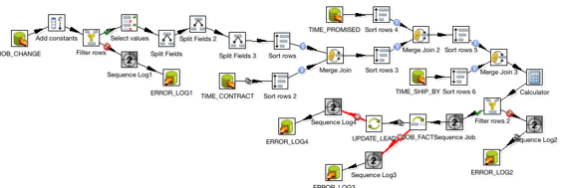

The expected output of the transformation is shown below:

